Rawls “Political Not Metaphysical”

- Let’s start by recalling where are we at the beginning of this article:

  - TJ has been out 15 years and subject to enormous amounts of attention.

  - Since publication of TJ, Rawls has published other major work – most notably “Kantian Constructivism in Moral Theory”, the high water mark of his Kantianism.

  - This article presents what looks like a new way of interpreting justice as fairness. We will want to ask:

    - Is Rawls making new claims about the theory introduced in TJ or should we have read the book in the way he is now presenting it?

    - Why introduce the interpretation of this article?

      - To eliminate misunderstanding in some of the literature on TJ

      - Rawls has come to think the stability arguments in TJ didn’t work, and that he needs to treat the subject in a different way: stability will be account for by an overlapping consensus

    - To see why, let’s recall where in Rawls’s work his Kantianism has played a role

      - There is a Kantian interpretation to the OP and the principles - Do not think it plays a role in the argument for the principles

      - Plays important roles in arguments for stability:

        - Chapter 8 - Connection between moral and natural attitudes,
        - Chapter 9’s argument for congruence

ASK: What might there be a problem with relying on claims drawn from the Kantian interpretation?

- Some of the most notable claims early in the article:

  - Wants to avoid “claims to universal truth” and “claims about the essential nature and identity of persons” (p. 223).

    - Can political philosophy avoid such claims?

    - If so, how must Rawls construe “claims about the essential nature and identify of persons” (see 230-31)

    - Even if Rawls can avoid relying on such claims, is his doing so is consistent with TJ?

  - What is the new methodology for political philosophy:

    - What is a political conception of justice as opposed to a general moral conception – p. 225

      - Worked out for basic structure

      - What’s the argument that societies can’t be well-ordered by general moral conceptions? How does this connect with the idea of applying the principle of toleration to philosophy itself? With the “method of avoidance” (231)?

    - Why start with “basic intuitive ideas”?

      - What are they? Note that the phrase occurs at TJ, p. 46. What does it mean there?

      - Are the basic intuitive ideas supposed to justify the theory built on them? If so, what authority do they have? Is Rawls committed to some kind of conventionalism or relativism? In this connection, recall the remarks in TJ, §87 about how justification always proceeds from agreement.

- Note that the aim is said to be to find a basis of social cooperation and mutual respect by reconciling a tension within the democratic tradition.

  - Is this what philosophy is supposed to do? Is there any conception of philosophy according to which this is what philosophy should try to do?

  - Note the view of justification that goes along with this at pp. 229-30.

  - Is Rawls right that the only alternative to accepting pluralism is “the autocratic use of state power”?

  - What claims about the essential nature and identity of persons does Rawls want to avoid? (see 230-31) Is the Kantian conception of TJ such a conception?

- Let us now survey basic intuitive ideas -

N.B. Both said to be drawn from public political culture. Is he right about this? How would he prove it?

  - What are the elements of social cooperation?

  - Elements of the conception of the person statement of the fundamental problem on p. 234. Is Rawls right about what the fundamental problem of contemporary political philosophy is?

- The original position:

  - Clearer than he had been – terms of social cooperation are thought of as set by us – p. 235

  - What is meant by saying that OP is device of representation (p. 237) and who is he trying to rebut?

  - Explain the two important footnotes at p. 237: notes 19 on conception-based view and 20 on rational choice

  - Is Rawls really right to stress that his early conception was un-metaphysical, as he does on p. 239?

- Now let’s look at the conception of free person at pp. 243-44

  - In what does our freedom consist?

  - Can this view of freedom really be found in or abstracted from public political culture?

- What is a comprehensive doctrine?

  - Explain the difference between a comprehensive doctrine and a political conception of justice.

  - Why would casting justice as fairness as something other than political be incompatible with liberalism?

- Let’s work through the last section with care since it seems to promise a new account of stability:

  - What is an overlapping consensus – pp. 225-6, pp. 246ff.?

  - Contrast with modus vivendi

  - Contrast with views according to which there is just one rational good – pp, 248-49 (including j as f in TJ)

  - Why does Rawls think the priority of right is “essential to any conception of justice reasonable for a democratic state”? (p. 250) Is he right?

  - Is Rawls right to contrast his view with those which are founded on skepticism?

  - Explain the last footnote of the paper.

Rorty, “Priority of Philosophy to Democracy”

- What is the “Enlightenment compromise” and its “rationalist justification”? (p. 176)

  - What are the reactions exemplified by Dworkin and Rawls?

  - What is the defining feature of communitarianism?

    - What are its three strands?

    - Why does the third strand raise the questions:

      - Why, if at all, does liberal democracy need philosophical justification?

      - Does a conception of the self that makes the community constitutive of the individual fit better with liberal democracy than that associated with the rationalist justification of liberal democracy?

- Explain Rorty’s remark that Rawls can:

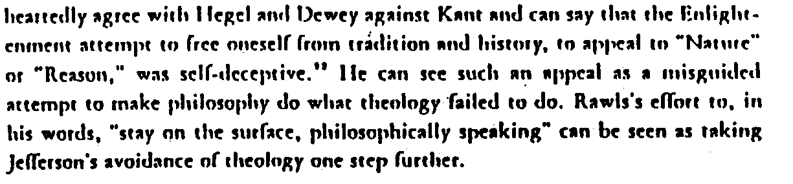

- And his claim that because Rawls thinks justice is the:

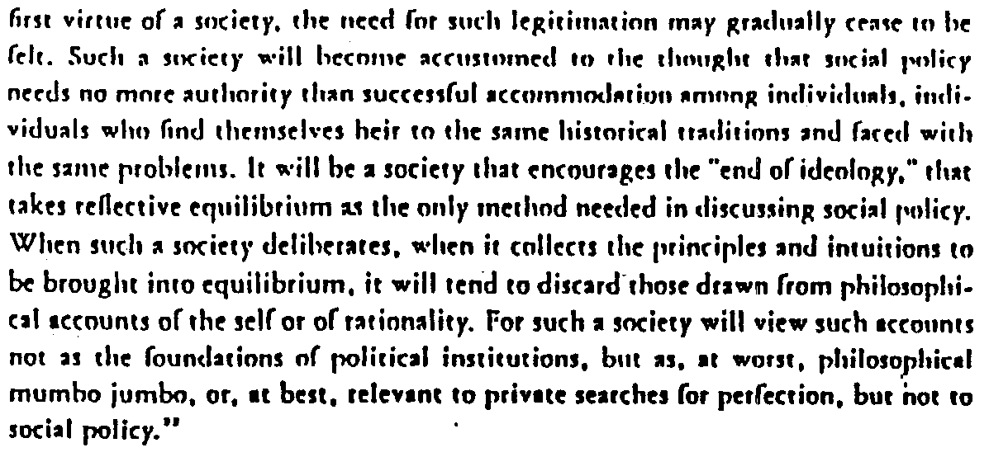

- Consider Rorty’s remark on p. 185 that, read in light of “Political not Metaphysical”, “Theory of Justice no longer seems committed to a philosophical account of the human self, but only to a historical sociological description of the way we live now.”

  - Explain the passage from “P not M” that Rorty draws on to sustain this reading of TJ.

  - Has Rorty interpreted the passage and TJ correctly?

  - Now consider Rawls’s remark at “P not M”, p. 247 that justice as fairness “is no less a moral conception because it is restricted to the basic structure of society.” What does Rawls mean by this? Can Rorty’s reading be squared with it?

- Consider the following remark from p. 193:

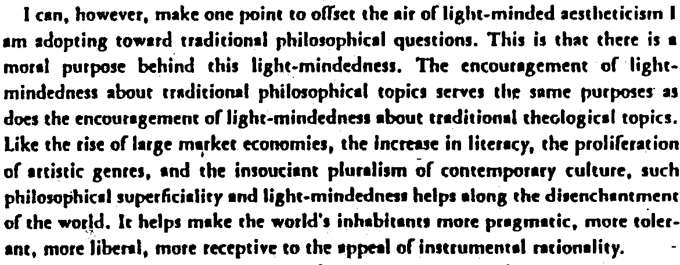

  - What does Rorty mean by “the disenchantment of the world”?

  - What is light-mindedness and why is Rorty in favor of it?

  - Now recall goodness as rationality. It is not too much of a stretch to read Rorty as arguing that light-mindedness is a broad-based quality that it would be rational for citizens of the well-ordered society would want in one another. If Rorty is right about that, then it follows from goodness as rationality that that quality is a virtue. Is it? Would Rawls agree?

- What does Rorty mean by the phrase on p. 192, which echoes his title, that “democracy takes precedence over philosophy”?

  - Is he right to imply that liberal democracy can get by without philosophical foundations in natural law or a conception of human nature? Would Rawls agree with the implication? If so, would he mean by it what Rorty does?

